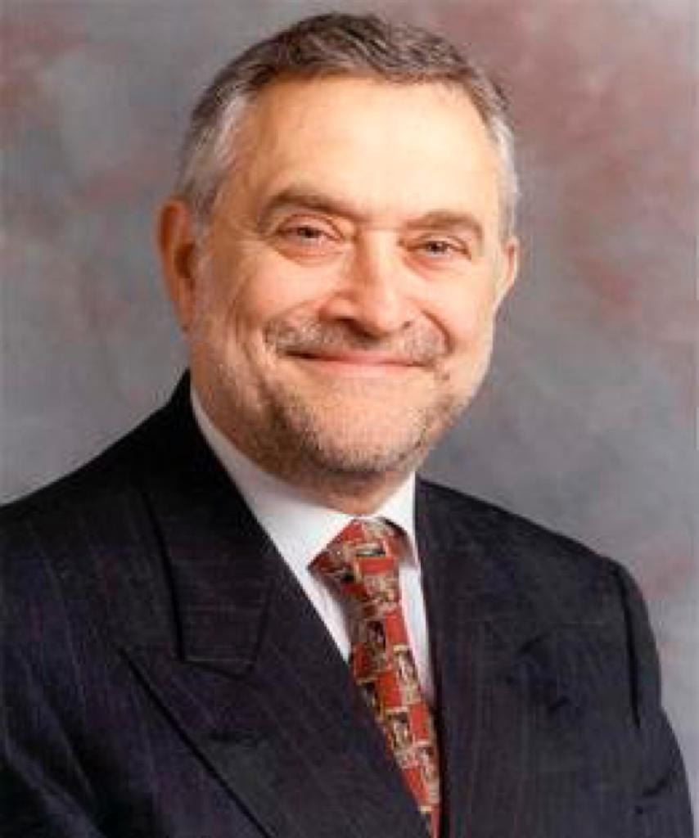

**Version 20 10 19**

**Career History**

Salvador Moncada, MD, obtained his PhD in the early 1970s at the Royal College of Surgeons in London, where he contributed to the discovery that aspirin-like drugs inhibit prostaglandin biosynthesis, thus accounting for their analgesic, anti-pyretic and anti-inflammatory actions.

In 1975 he joined the Wellcome Research Laboratories where, as Head of the Department of Prostaglandin Research, he initiated and led the work that resulted in the discovery of the enzyme thromboxane synthase and the vasodilator prostacyclin. This work is the basis for the understanding of how low doses of aspirin prevents cardiovascular episodes such as myocardial infarction and stroke and also explains the cardiovascular side effects of the anti-inflammatory drugs called, COX2 inhibitors”.

He was Director of Research at the Wellcome Research Laboratories from 1986 until 1995, during which time he oversaw the discovery and development of a number of drugs, including lamotrigine (anti-epileptic), zomig (anti-migraine), atovaquone (anti-malarial) and the initiation of the project which led to the finding and development of lapatinib (anti-cancer).

In 1985 he began a project that led to the identification of nitric oxide (NO) as the biological mediator formerly known as endothelium-derived relaxing factor. He elucidated the pathway of the synthesis of NO from the amino acid L-arginine and discovered many of the biological activities of this novel mediator. The finding that NO is generated in the central nervous system led him to propose that the L-arginine: NO pathway is a widespread transduction mechanism for regulating cell function and communication.

In 1996 Prof. Moncada moved to University College London to establish and direct the Wolfson Institute for Biomedical Research. The aim of this Institute was to set up a Centre of excellence in biomedical research that provided an interface between academia and industry, thus establishing one of the earliest units for translational research in the UK. This approach led to the spinning out up of a number companies, including Ark Therapeutics (vascular disease and cancer), Arrow Therapeutics (anti-infective drugs), CereXus (neuroscience), Inpharmatica (bioinformatics) and ProAxon (sodium channel blockers).

At the invitation of the Spanish Government, between 1999 and 2004 Professor Moncada conceived, designed and developed the Centro Nacional de Investigaciones Cardiovasculares (CNIC) in Madrid.

In the last decade his work has focused on the interaction between NO and cytochrome c oxidase, the terminal enzyme of the mitochondrial electron transport chain. This work has established the role of NO as a physiological regulator of cell respiration and a cell signaling molecule in response to stress. In addition, he has shown that interactions between NO and oxygen at the level of cytochrome c oxidase might also initiate pathophysiology.  His finding that NO is involved in mitochondrial biogenesis has implications for the understanding of metabolic syndrome, type-2 diabetes and obesity.

His interest in glycolysis has led him, in recent years, to the identification of a molecular mechanism that coordinates cell proliferation with the provision of the metabolic substrates required for this process.  This research has significant implications for the understanding of normal and abnormal cell proliferation, for example in cancer.

In October 2013 Prof Moncada became Emeritus Professor of Experimental Biology and Therapeutics at University College London and Professor of Translational Medicine and Strategic Advisor at the University of Manchester.  In January 2014 he took on the role of Institute Director of Cancer Sciences, Faculty of Medical and Human Sciences, University of Manchester and later Cancer Domain Director until June 2018.

. Professor Moncada is a Fellow of the Royal Society and a Foreign Associate of the National Academy of Science of the USA. He has received numerous international awards and honorary doctorates from more than 20 Universities around the world. In 2010 he received a Knighthood from Queen Elizabeth the II for his services to Science.

Prof. Moncada’s research has had a major impact as shown by his standing in the international citation indexes and his acknowledgement as the most cited UK scientist in biomedicine in the 1990s.